# 1 Planning 模块的整体架构

L3自动驾驶系统包含多种感知传感器，和定位地图服务，需要底盘和动力系统保证最终执行。在整个应用层中，包含感知模块PER，地图模块MAP，定位和自车状态模块LOC+Odometer，规划模块planning，功能模块FCT ，运动控制模块controler。感知PER提供动态障碍物，车道线等环境信息，

定位模块，提供自车绝对定位和车辆运动状态信息，如经纬度，车速等;

地图MAP模块，提高高速、高架的车道拓扑信息，当高速导航自动驾驶功能开启，FCT模块会发送功能激活请求给planning模块，planning 根据地图和当前自车定位规划出到达目的地的最佳路线，结合实时感知信息，planning 模块会评估最佳运动行为，规划出最佳轨迹，发送给运动模型模块controller做运动执行。

planning模块内部划分为环境建模，预测，行为规划，轨迹规划。

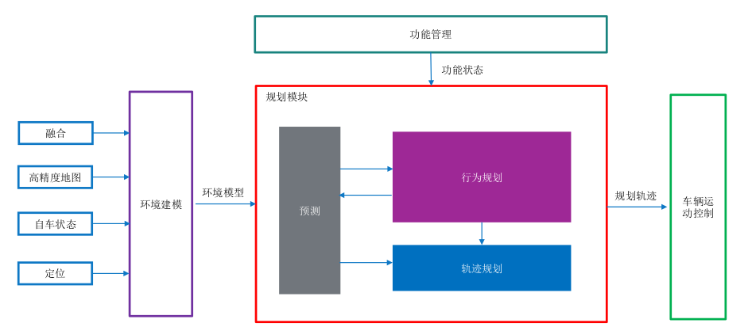

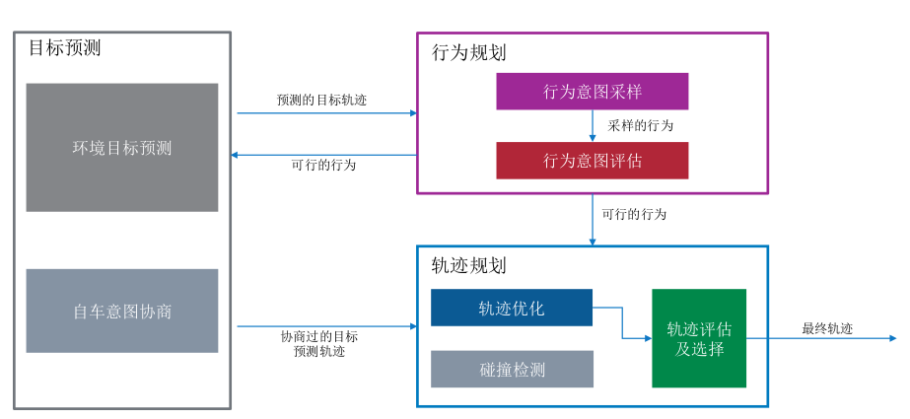

# 2 Planning Functional Subsystem

# 2 规划功能子系统

## 2.1 Environment Model 环境建模

### 2.1.1 Perception

The perception information mainly includes:

- dynamic world

- static world

- free space, indicates the space could be traversed by vehicles

- visible grid map, the grid value indicates whether the grid could be detected by any sensor

### 2.1.2 Road Topology

The environment model shall provide the following information of road topology:

- global routing info

- road segment list

- lane net list

- road edge list

- stop line list

- cross walk list

- traffic sign list

- traffic light list

- parking slot list

- reference line

- keep clear region list

- intersection

### 2.1.3 Map information

The environment model shall provide function to search and extract map information including:

- lane net

- lane relation

- crossing walk

- stop point(or stop line)

### 2.1.4 Localization

The environment model shall provide the following localization information:

- time stamp(UTC)

- global pose in WGS84 coordinate

- pose (x,y,z) and their variance in local coordinate frame

- linear speed(vx, vy, vy) and their variance in ego vehicle frame

- linear acceleration(ax, ay, az) and their variance in ego vehicle frame

- euler angle(roll, pitch,yaw ) and their variance in local coordinate frame

- angular velocity(rollrate, pitchrate, yawrate ) in ego vehicle frame

- localization status(ok, not ok)

## 2.2 Prediction

### 2.2.1 trajectory prediction

The prediction module provides the estimated future info of objects.

Prediction module shall provide trajectory prediction for cyclist for future p_MAX_pred_time seconds with each step being p_pred_step_time s. Predicted information shall include:

- position;

- velocity;

- orientation;

### 2.2.2 intent prediction

Prediction module shall provide intent prediction for vehicle. 预测交通参与者可能会执行的行为

Intent shall include:

- lane keeping

- left lane change

- right lane change

- left turn

- right turn

- U turn

## 2.3 Function Manager

The function manager shall output the following evaluations for the supported behaviors requested by FCT:

- Assessment, reflecting confidence that its model assumptions are fulfilled and that it can assess the current situation and behavior accurately;

- Driver intention match, implement the driver's agreement with the behavior;

- Necessity, which can be summarized as the collision probability of ego vehicle with an object (pedestrian, cyclist, vehicle, road side boundary) or regulation (lane lines) if the course of the ego vehicle is not altered.

- Collision Probability, which is interpreted as the collision probability conditioned on the system reaction being executed continuously.

- Whether valid and recommended (m_reactionPattern.isValid or m_isReactionPatternValid)

The function manager shall at least output the intention values for the following behaviors requested by FCT:

- ALD_LongLat

- ALD_Long

- ALC_Left_LongLat

- ALC_Right_LongLat

- E2E_highway

- E2E_urban

## 2.4 Behavior Planner

**Driving scenarios，行为规划模块提供了多种驾驶场景的行为**

行为规划：

环境坐标转化：转换为frenet坐标系

搜索算法：A*

曲线选择：cost计算

The behavior planner is a module which provides the behavior level info for trajectory planning module as input.

The behavior planner shall consider multiple trajectories predicted by prediction module to make a decision.

The behavior planner shall provide required inputs for the trajectory planner.

### 2.4.1 Adaptive Cruise Control

**2.4.1.1 The feature (Adaptive) Cruise Control ((A)CC) extends the functionality of the conventional cruise control.**

**Besides holding a speed set by the driver, the feature can automatically adapt the velocity in order to keep a safe distance to driving vehicles, when in Adaptive Cruise Control Mode.**

**The security distance is chosen by the driver in form of a time-gap. If the preceding vehicle is not detected any more, the Adaptive Cruise Control feature returns to the driver desired speed and behaves like conventional cruise control.**

自适应巡航控制（ACC）扩展了传统巡航控制的功能。除了保持驾驶员设置的速度外，该功能还可以自动调整速度，以保持与前车的安全距离，当处于自适应巡航控制模式时。安全距离由驾驶员以时间间隔的形式选择。如果不再检测到前车，则自适应巡航控制功能会返回到驾驶员期望的速度，并像传统巡航控制一样运行。

#### 2.4.2.1.1 Free Cruise

2.4.1.1 The behavior planner shall detect potential target objects when ACC is requested by FCT including:

1. Leading object

2. 2nd leading object

3. Leading object on the left adjacent lane

4. Leading object on the right adjacent lane

5. ACC selected object

The behavior planner shall consider stationary vehicles which are in the path of the ego vehicle for speeds of ego of maximum #p_ACC_MaxSpeedForStaticObject.

The behavior planner shall distinguish the potential target object as cars, trucks, motor cycle, pedestrians and stationary objects according to fusion results.

The behavior planner shall consider targets with relative velocity between [VALUE 1] m/s and [VALUE 2] m/s.

Non-stationary objects moving in the opposite direction shall not be considered as target object.

Objects moving in the opposite direction is defined as:

• Vx of the object is negative.

• Absolute value of Vy of the object is less than #p_ACC_OnComingObj_Vy_thresld.

The TargetDetectionRegionOfInterest shall be defined as

• Region of Interest longitudinal: 0.2m - 180m long from VehicleCoordinateSystemOrigin

• Region of Interest lateral: +/-8m wide from VehicleCoordinateSystemOrigin.

• Field of view longitudinal:

• up to 25m: +/- 45°

• up to 60m: +/- 20°

• up to 110m: +/- 10°

• up to 180m: +/- 5°

• Field of view left corner: 150°

• Field of view right corner: 150°

If there is more than one forward vehicle on straight roads and in steady-state curves, the forward vehicle in the subject vehicle's path shall be selected for ACC control in typical ACC situations.

If NO line markings are available from environment model, the behavior planner shall determine a virtual lane.

The behavior planner shall associate confirmed target objects with the identified lanes.

The behavior planner shall select the target object from the list of possible target objects.

Note: List of possible target objects contains possible targets in the ego lane or in the neighbouring lanes.

Possible target objects shall be selected from:

• ForwardTarget: Closest target object in front of the ego vehicle in the trajectory.

• AheadTarget: Second closest target object in front of the ego vehicle in the trajectory.

• FrontLeftTarget: Closest target on the left side of the ego vehicle's trajectory.

• FrontRightTarget: Closest target on the right side of the ego vehicle's trajectory.

• StoppedTarget: Target object which was detected moving before and now come to stationary in the ego vehicle's trajectory path.

• StationaryInPathVehicle: Stationary target object(object which is not seen as moving by the system) in the ego vehicle's trajectory path.

The environment model shall provide the following general information of each dynamic object in local coordinate frame:

- ID

- object classification

- object classification confidence

- reference position and variance

- reference position type

- lateral speed, longitudinal speed, lateral acceleration,longitudinal acceleration,orientation and their variance

- associated agent information

- object shape, represented by polygon

- bounding box, contains length, width, height, heading and center point

- history trajectory within p_History_Traj_Duration s

- two associated lane ID and probability

- contribute sensor

- state of static, contains: moving, stopped, stationary, unknown

- exist probability

- moving direction

当自适应巡航（ACC）由FCT请求时，行为规划应该检测到潜在的目标对象，包括：

1. 前方对象
2. 第二前方对象
3. 左侧相邻车道的前方对象
4. 右侧相邻车道的前方对象
5. ACC选择的对象

行为规划应考虑在自车路径上的静止车辆，对于自车速度不超过最大速度 #p_ACC_MaxSpeedForStaticObject。

#### 2.4.2.1.2 Approaching

#### 2.4.2.1.3 Approaching VRUs (none static)

#### 2.4.2.1.4 Vehicle Following

#### 2.4.2.1.5 Drive off

#### 2.4.2.1.6 Intruder detection - OBSOLETE

#### 2.4.2.1.7 Stopping

#### 2.4.2.1.8 Approaching Stationary Vehicle

#### 2.4.2.1.9 Preceding Vehicle Cut-in

#### 2.4.2.1.10 Preceding Vehicle Cut-out

#### 2.4.2.1.11 Curve Driving

#### 2.4.2.1.12 Reaction on non-relevant objects

#### 2.4.2.1.13 Take over request

### 2.4.2 In-lane Driving (TJA/ICA)

#### 2.4.2.2.1 Without preceding vehicle

#### 2.4.2.2.2 With preceding vehicle

### 2.4.3 Automatic Lane Change (ALC)

The behavior planner shall propose a behavior to let ego complete lane change manoeuvre and the ego vehicle front tire shall touch the line between the origin lane and target lane after 2.0 seconds and not later than 4.0 seconds after the starting of lateral movement towards target corridor.

background: UN ECE-R79 5.6.4.4.

### 2.4.4 End to End

#### 1 Lane following

The Behavior Planner shall working properly to drive safely, efficiently and comfortably under Lane-Following status in below scenarios:

- Stop & Go traffic situation;

- Driving in lane with vulnerable road users;

- Driving in lane with crosswalk in front;

- Static objects in the ego driving lane in front;

- Other vehicle cutin into ego driving lane;

- Neighbor lane with parked vehicles, vehicles parking out, parked vehicles with door open;

- Passing through truck driving on neighbor lane;

- Driving in lane in tunnel;

- Entering new speed limit zone indicated by new speed limit sign;

- Driving in big curvature lane;

#### 2 Lane change procedure

#### 3 Lane Merge/Split

#### 4 Urban E2E Intersection

#### 5 Urban E2E Roundabout

#### 6 Safe Stop

The behavior planner shall propose a safe stop behavior to let ego stop with deceleration lower than p_u_Safestop_Axlimit if safe stop is requested by FCT.

#### 7 Intelligent evasion

#### 8 Intelligent Speed adaption(ISA)

#### 9 Side Pass

#### 10 Driver override

## 2.5 Motion Planner

路径规划：

路经编码：贝赛尔曲线

动态目标避障：

The trajectory planner receives the environment model info and behavior planning result, plans a trajectory for ego vehicle to follow

The trajectory planner shall plan a furture trajectory for ego vehicle for p_max_plan_horizon s

**Remark:p_max_plan_horizon=8s**

基础信息：

Coordinate introduction:

- Local Coordinate Frame

This coordinate frame uses the initial position when turned on as origin point, and the vehicle direction as axis orientation, updates with odometry accumulation and localization delta.

- Frenet Coordinate Frame

This cooridnate frame is built based on a reference line, uses the distance along the ref line as S direction, the distance in normal direction to the ref line point as L direction.

- Ego Vehicle Coordinate Frame

This coordinate frame origin is within the center point of the rear axle of the ego vehicle. Its x-axis points towards the positive driving direction. The y-axis towards the left side and the z-axis out of the plane of drawing.

The environment model shall provide time synchronization to:

- dynamic object

- static world

- odometry

- localization information.

**3 Planning Non-Functional Requiremnets**

**4 Planning Safety Requirements**

基于现有的高速领航辅助功能进行裁剪,降级车速，禁掉变道功能， 禁掉脱手检测，限制功能ODD等

适配冗余底盘等矩阵

开发DSSAD功能(基于GBT自动驾驶数据记录系统-20220730讨论稿)

开发必要的降级策略